**PIZZA SALES REPORT:**

1.What is the total Revenue?

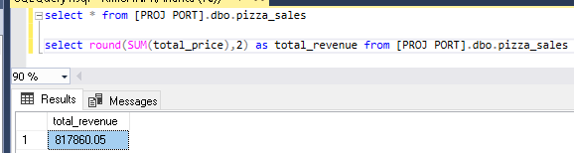

2.What is the Average order value?

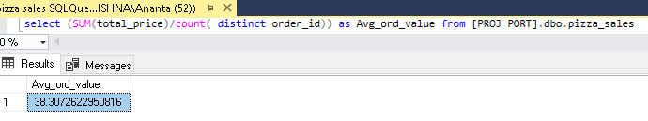

3.What is the total no of pizzas sold?

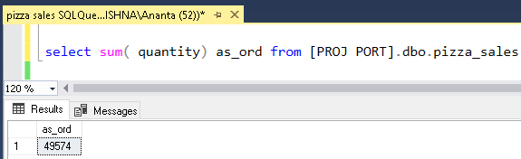

4. What is the total order placed?

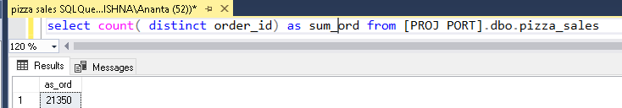

5.Daily trend for total order?

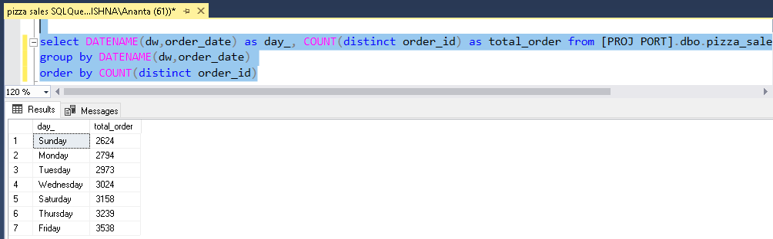

6.hourly trend for total order?

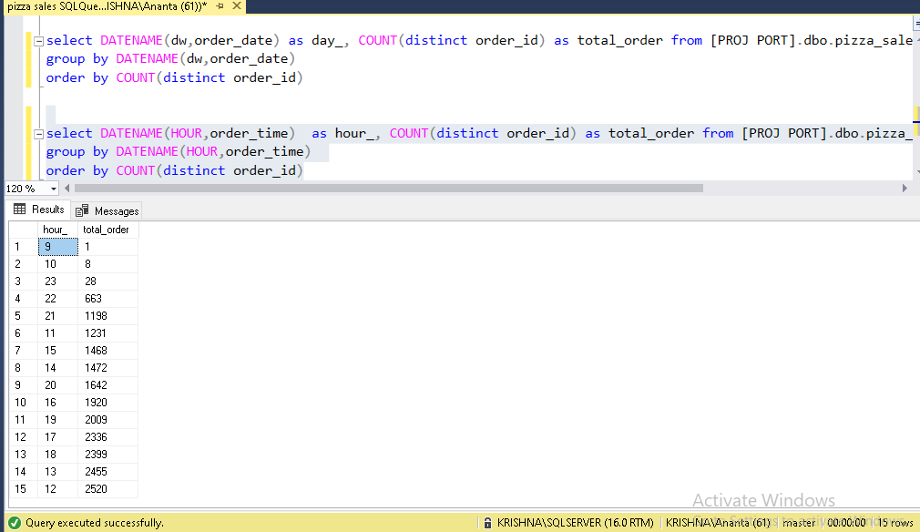

7.Monthly trend for total order?

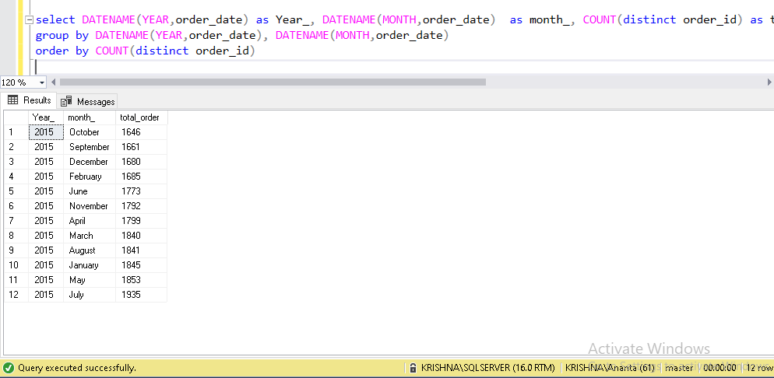

8. % of sales by pizza Category?

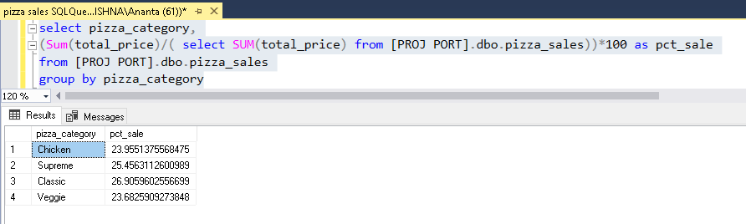

9. % of sales by pizza Size?

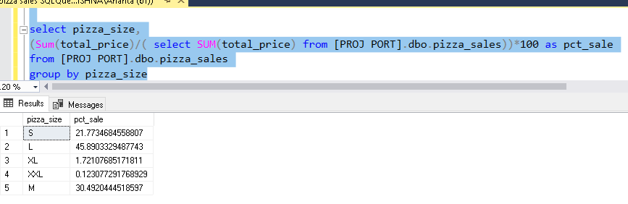

10. Top and bottom 5 pizzas name w.r.t revenue, quantity and orders:

